|  |  |
| --- | --- |
| /Users/localadmin/Desktop/Logo 2017 Where your future begins logo.jpg | Mindarie Senior College  Mathematical Methods Unit 4  **Investigation 3 2018 (7%)**  **Time Allowed: 50 mins** |
| **Calculators allowed. One page (two sides) of notes permitted.**  **Show all working for full marks to be given.**  **Name : Total Marks: 35** | |

**Part 1 Real world data and sampling**

**Question 1 [2 marks]**

Why is sampling an important process in today’s world?

**Question 2 [2 marks]**

Read the excerpt taken from an online news website and then comment on the Australian statistic mentioned.

**The Middle East is in the middle of a hellish heatwave right now**

***AUGUST 13, 2016***

THOUGHT your average Aussie summer was rough? The Middle East is currently facing one of its most extreme heatwaves ever, with experts warning temperatures are getting almost too hot for human survival. Climate scientists say it’s evidence that the planet needs to cut down on its greenhouse gas emissions, especially given heatwaves can be fatal.

HOW HOT IS THE MIDDLE EAST RIGHT NOW?

Over the past month, temperatures in Kuwait and Iraq have soared to 54°C, while Baghdad, the capital of Iraq, has seen temperatures of 43°C and higher nearly every day for almost two straight months.

Meanwhile, parts of the United Arab Emirates and Iran were dealt historic temperatures reaching 60°C.

To put that into perspective, the hottest single day on record for the whole of Australia was 40·3°C, back in January 2013. Zainab Guman, a 26-year-old university student from Basra, told [The Washington Post](https://www.washingtonpost.com/world/middle_east/an-epic-middle-east-heat-wave-could-be-global-warmings-hellish-curtain-raiser/2016/08/09/c8c717d4-5992-11e6-8b48-0cb344221131_story.html) it felt like “walking into a fire” when she left the house.

**Question 3 [6 marks]**

The Principal has met with you and you have been given the task of selecting a random sample of students from the school population to administer a simple questionnaire to them. The students will each be given the same questionnaire on the following topics: mobile phone use, uniforms and silent reading. The questionnaire has already been designed for you.

Student numbers in the school:

Year 7 : 280 Year 8 : 260 Year 9 : 245

Year 10 : 260 Year 11 : 220 Year 12 : 215

Year lists of students are available to you in alphabetical order.

Describe in detail how you would carry out this task.

**Question 4 [2, 2, 2 = 6 marks]**

**Comment constructively on each of these situations.**

Situation One

The Shokken Electrical Company produces a key component for medical equipment. To save money, the company decides to test every 5th component.

Situation Two

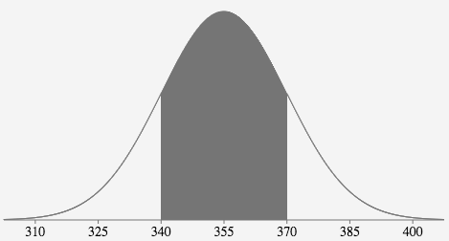Dodgy Dave produces 360g packets of oat bran in a factory.

A sample of 28 packets are weighed and the following data

is obtained as shown in the graph where the mean = 355g

and the standard deviation = 15g.

Situation Three

Jana’s friend Chris rolled a normal die four times and repeated that sampling process three times. The proportion of odd numbers in each sampling process are recorded as follows:

Sample 1 : 0·5 Sample 2 : 0·25 Sample 3 : 0·25

Jana concluded that the die must be biased or numbered with more even than odd numbers, possibly like this 1, 2, 2, 3, 4, 4.

**Part 2 Simulation problems**

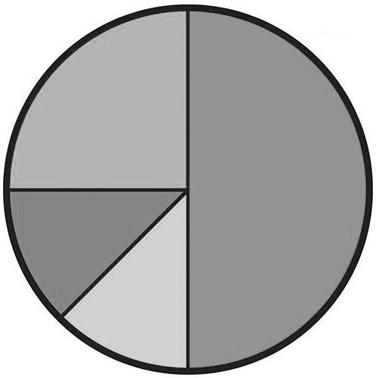

1

2

3

4

**Question 5 [3, 4 = 7 marks]**

This spinner has four different sections. Acute angles are 45°.

a) Design a simulation for this spinner. Describe how your

simulation will work.

b) Run your simulation 20 times. Record your results in a neat and organised way.

Comment on and compare your results to what is expected.

**Question 6 [2, 1, 2, 2, 1, 4 = 12 marks]**

A sample is drawn from a normal distribution where the mean = 65 and SD = 11.

For this sample, mean = 64·2 and standard deviation = 10·6.

|  |  |  |  |  |  |  |  |  |  |  |  |  |  |  |  |  |  |  |  |
| --- | --- | --- | --- | --- | --- | --- | --- | --- | --- | --- | --- | --- | --- | --- | --- | --- | --- | --- | --- |
| 22 | 39 | 42 | 47 | 47 | 47 | 47 | 48 | 49 | 49 | 49 | 50 | 50 | 50 | 50 | 51 | 51 | 52 | 52 | 52 |
| 53 | 53 | 53 | 53 | 54 | 54 | 55 | 55 | 55 | 55 | 56 | 57 | 57 | 57 | 58 | 58 | 58 | 58 | 59 | 59 |
| 59 | 60 | 60 | 60 | 60 | 60 | 61 | 61 | 61 | 61 | 62 | 62 | 62 | 62 | 63 | 63 | 63 | 63 | 63 | 63 |
| 63 | 63 | 63 | 64 | 64 | 64 | 64 | 64 | 65 | 65 | 65 | 65 | 66 | 66 | 66 | 66 | 67 | 67 | 67 | 67 |
| 67 | 67 | 67 | 67 | 68 | 68 | 68 | 69 | 69 | 69 | 69 | 70 | 70 | 70 | 71 | 71 | 71 | 71 | 71 | 71 |
| 72 | 72 | 72 | 72 | 72 | 72 | 72 | 73 | 73 | 73 | 73 | 73 | 73 | 73 | 74 | 74 | 75 | 75 | 76 | 76 |
| 77 | 77 | 77 | 77 | 78 | 79 | 81 | 81 | 82 | 83 | 85 | 85 | 87 | 87 | 87 |  |  |  |  |  |

a) How many items are there in this sample? Is the sample size reasonable?

b) Why doesn’t the mean and standard deviation of the sample match the population measurements?

c) If somebody else saw this sample and wondered if data was missing from the blank cells in the

table what would your response be?

d) Randomly select 5 results from the sample above. Describe how you did this and list your sample

here.

**Question 6 continued**

e) How does your sample of 5 compare to the population and the sample given above?

f) Using randNorm(StDev, Mean, Sample size) on your calculator, generate your own sample

of 10 from the population where the Mean = 65 and standard deviation = 11. Round each item to the nearest whole number. List your sample here. Find the mean and standard deviation. Compare to other results mentioned in this question.